# CS 255 System Design Document

**By Mariam Haji**

## UML Diagrams

### UML Use Case Diagram

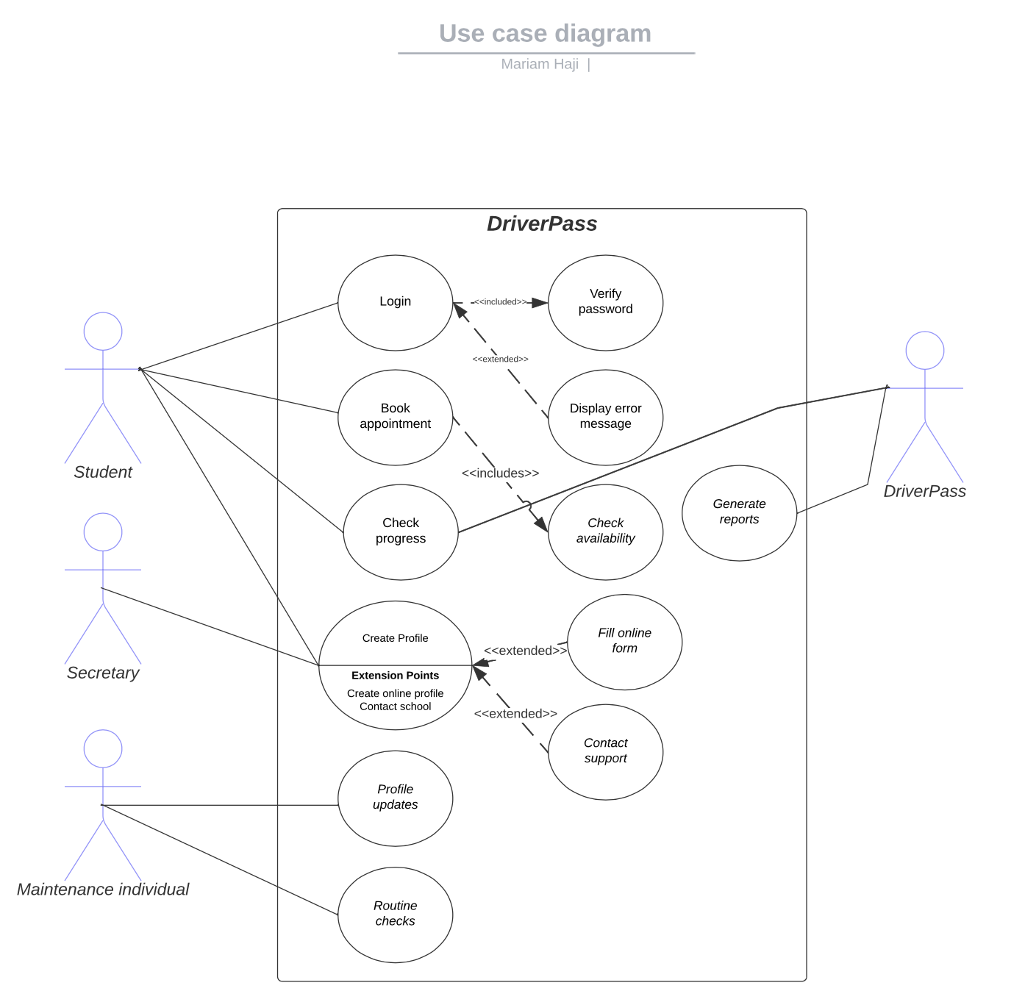

### Activity Diagrams

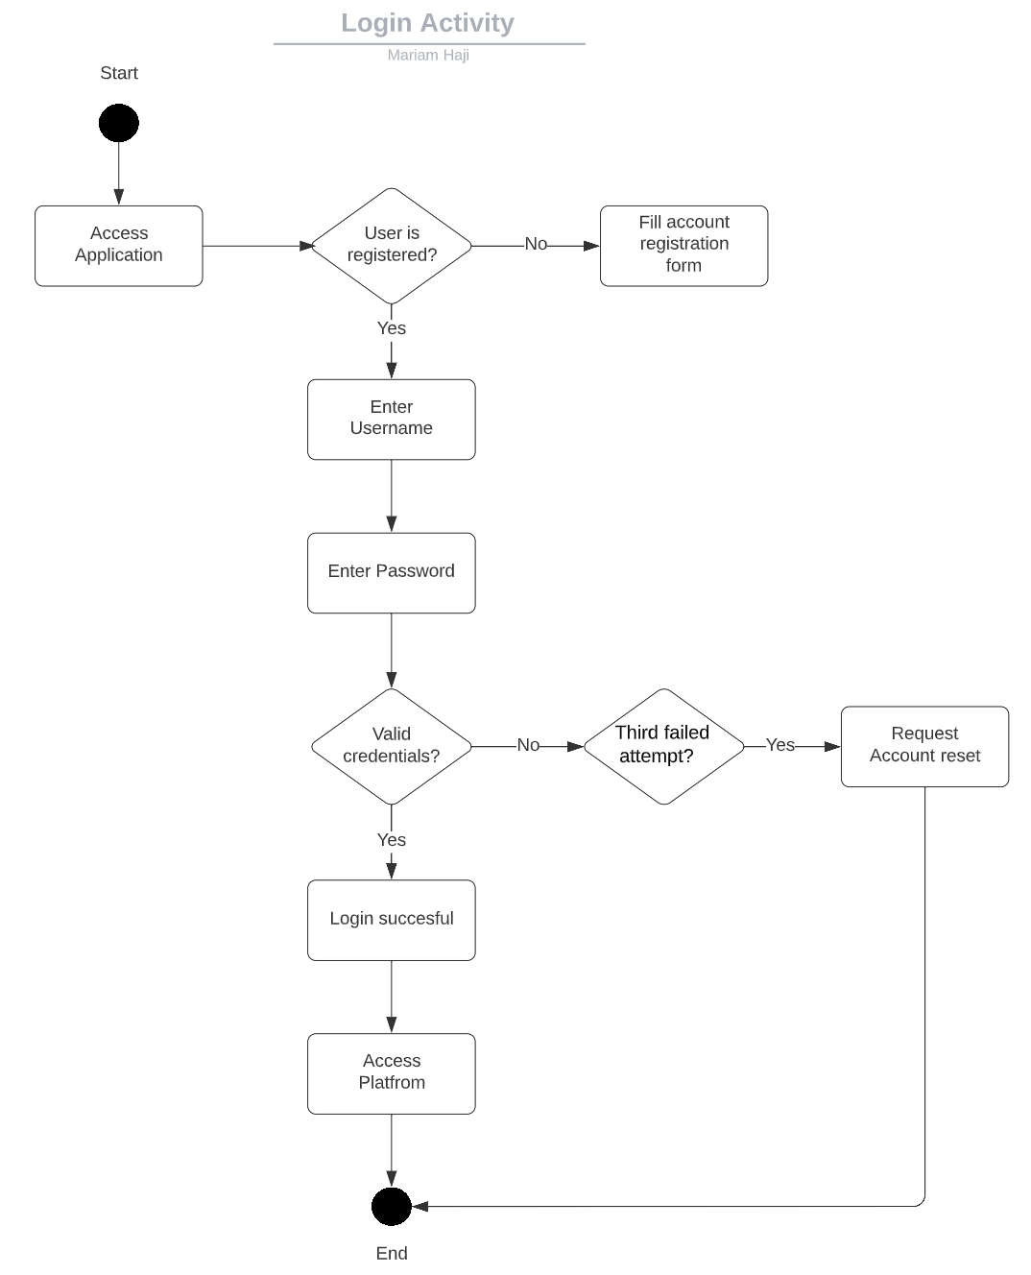

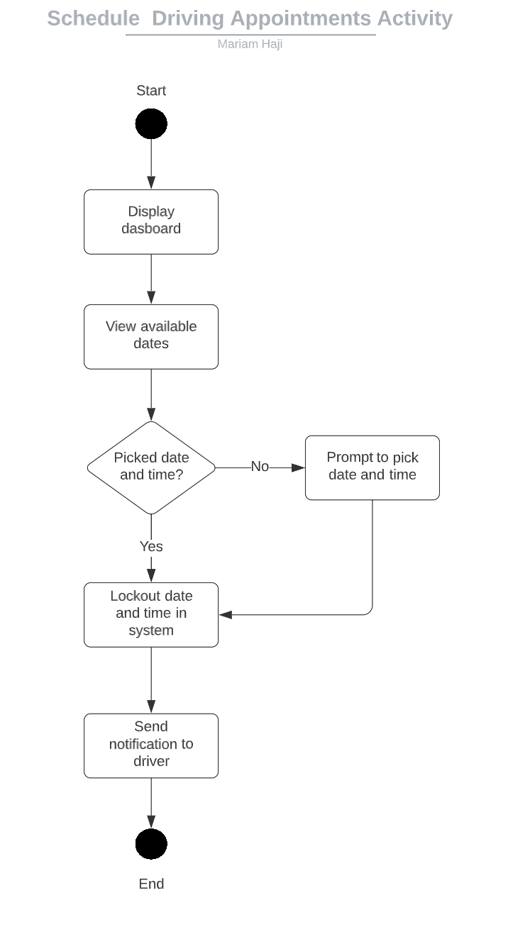

### UML Sequence Diagram

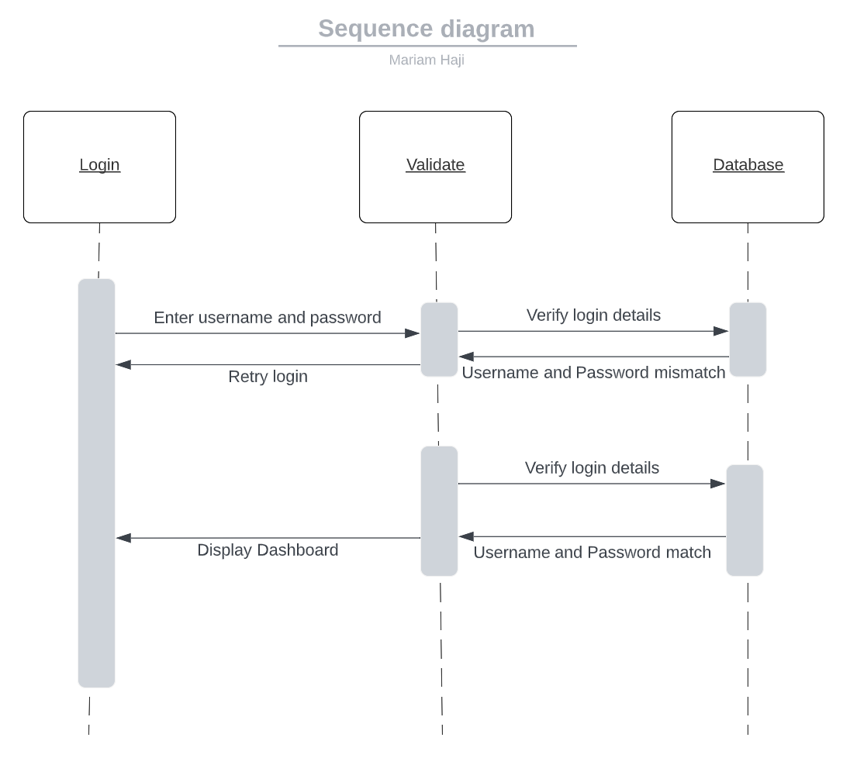

### UML Class Diagram

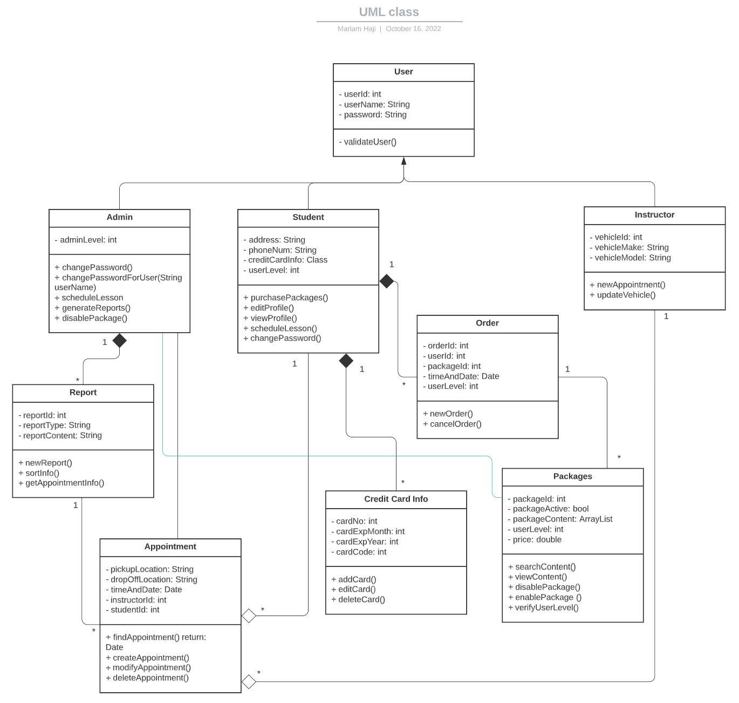

## Technical Requirements

**Hardware Requirements**

* Desktop or laptop computer
* Monitor, keyboard, and mouse for interaction
* Power sources
* Internet provider
* Wireless card or ethernet cable for networking

**Software Requirements,**

* Operating system
* Webbrowser
* DriverPass Software
* Cloud system for back and prevention of hacking and sensetive information

**Tools**

* Cloud system
* Integrated development environment (IDE) for developing the system
* Internet connection
* Programming software’s such as SQL for database

**Infrastructure Requirements**

* Cloud provider
* Power Supply
* Internet service
* Parking space
* Cars
* Credit card processing company